Experiment:11
AIM
To execute and analyze Nmap timing and performance commands in Kali Linux using Aggressive Speed Scan (-T4) and Insane Speed Scan (-T5).

ALGORITHM
- Open the Kali Linux Terminal.
- Create a text file using the command touch exp11.txt.
- Verify the file using the ls command.
- Execute the Aggressive Speed Scan using:
nmap -T4 scanme.nmap.org
- Observe and record the scan results, including the host status and open/closed ports.
- Execute the Insane Speed Scan using:
nmap -T5 scanme.nmap.org
- Observe the scan results and compare the scanning speed with the aggressive scan.
- Record the obtained results.
OUTPUT:
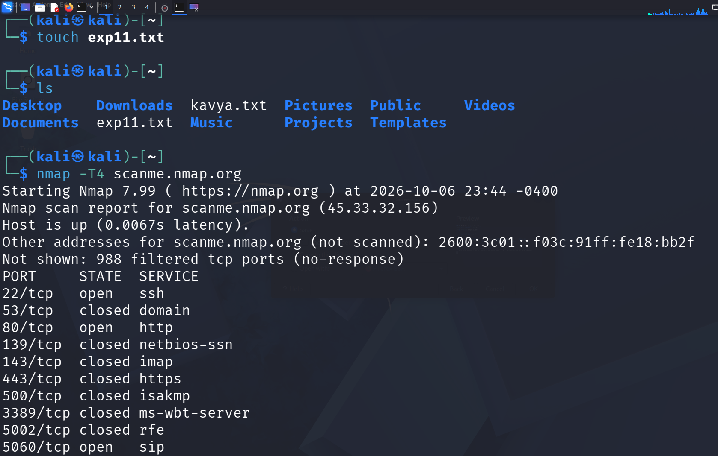
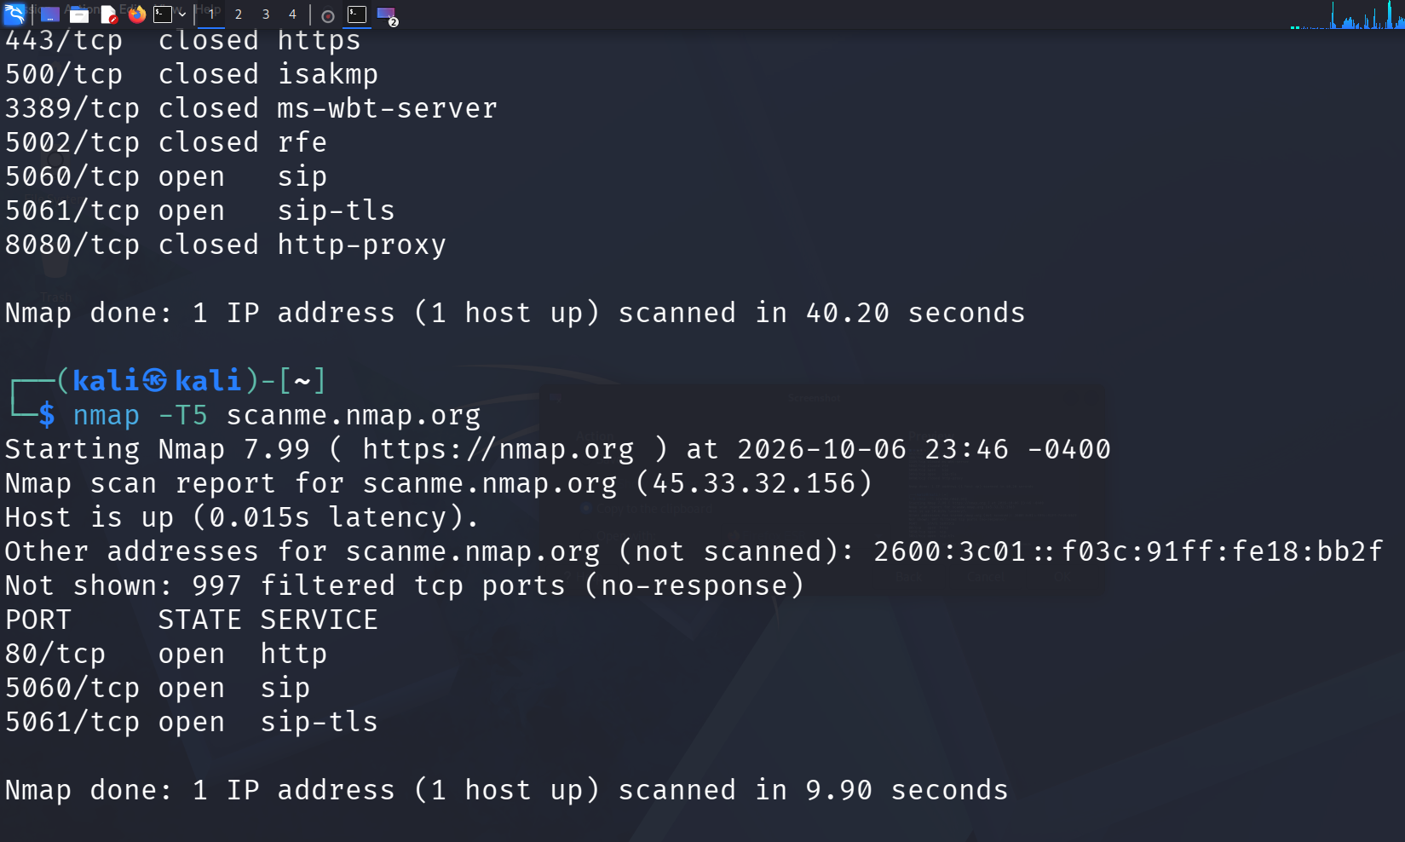
RESULT
The Nmap timing and performance scans were successfully executed in Kali Linux. The Aggressive Speed Scan (-T4) detected the target host and displayed its port and service information. The Insane Speed Scan (-T5) was also successfully executed with a higher scanning speed. Thus, the different Nmap timing options were successfully demonstrated.

